Ownership Certificate

To Whom It May Concern

This is to certify that the following equipment mentioned below are the sole owned by Sudhir Equipment Rental Company.

Equipment | Boom Lift
Brand / Make | JLG
Asset ID | S26SPJ-518
Model Number | X26JP
Serial Number | C170001714
Working Height | 26 Meter
Type | Compact Crawler boom Lift
Manufacturing Year | 2018

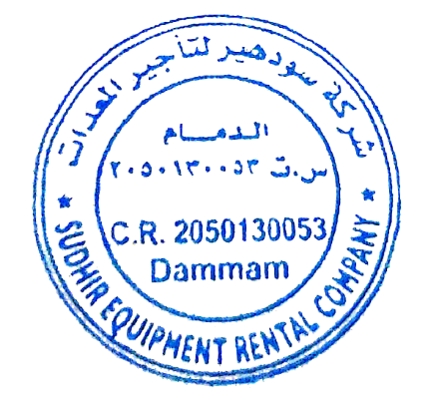
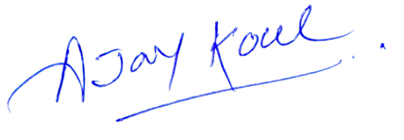
Sincerely,

Ajay Koul
General Manager

